VISITOR MANAGEMENT SYSTEM USING
SERVICENOW

Objective
The objective of the Visitor Management System (VMS) project is to automate and streamline the process of managing visitor registrations within an organization. The application enables visitors to submit visit requests, allows administrators to approve or reject requests, records visitor check-in and check-out activities, sends automated email notifications, generates reports and dashboards, and provides a centralized platform for tracking visitor information.The system improves security, reduces manual paperwork, enhances visitor tracking, and ensures efficient management of visitor activities through an automated workflow built on the ServiceNow platform.

Milestone 1: Project Planning and Environment Setup
Objective
To prepare the ServiceNow development environment and establish the foundation for the Visitor Management System (VMS) application. This phase includes setting up the ServiceNow instance, creating the scoped application, and planning the database structure required for managing visitors and employee hosts.
Step 1: Create Personal Developer Instance (PDI)
- Visit developer.servicenow.com.
- Sign in or create a developer account.
- Request a Personal Developer Instance.
- Wait for instance activation.
- Login using admin credentials.

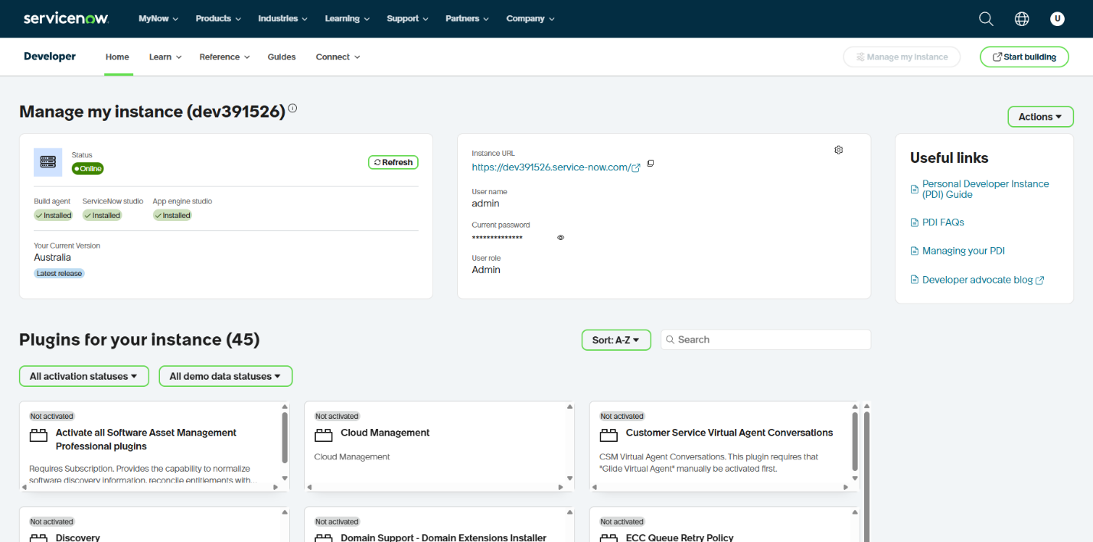
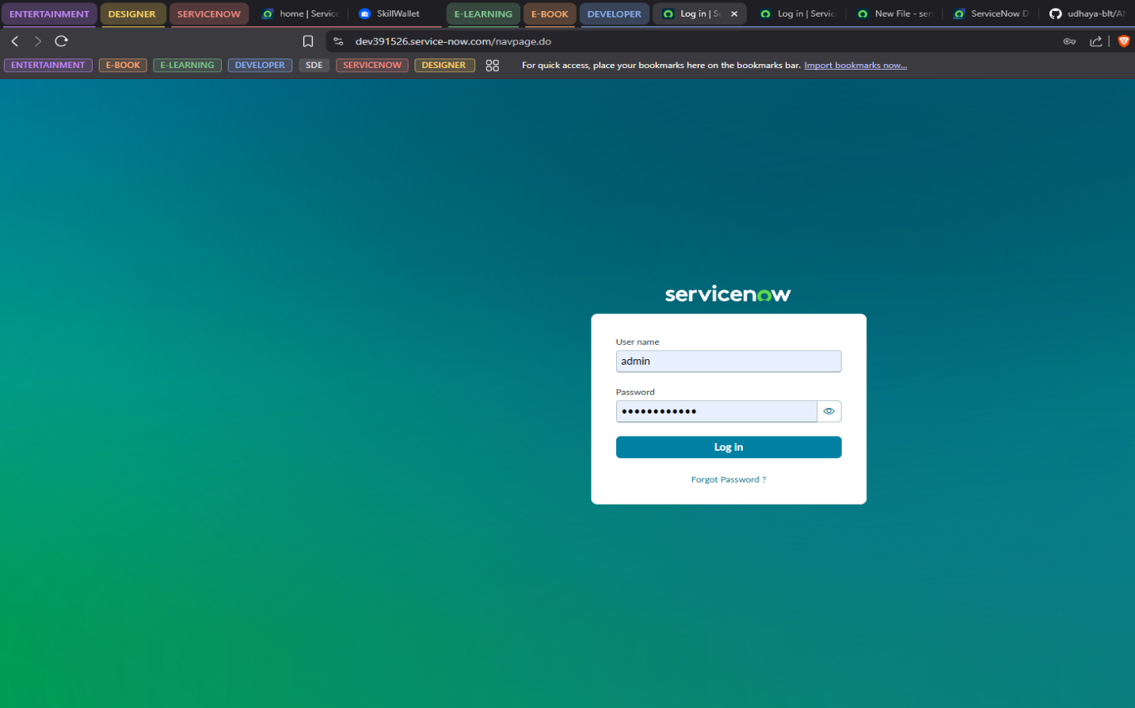

Step 2: Create Scoped Application
Navigation:
System Applications → Studio
- Open Studio.
- Select Create Application.
- Enter:
  - Application_Name
Visitor Management System
  - Scope: Auto-generated by ServiceNow
- Click Create.
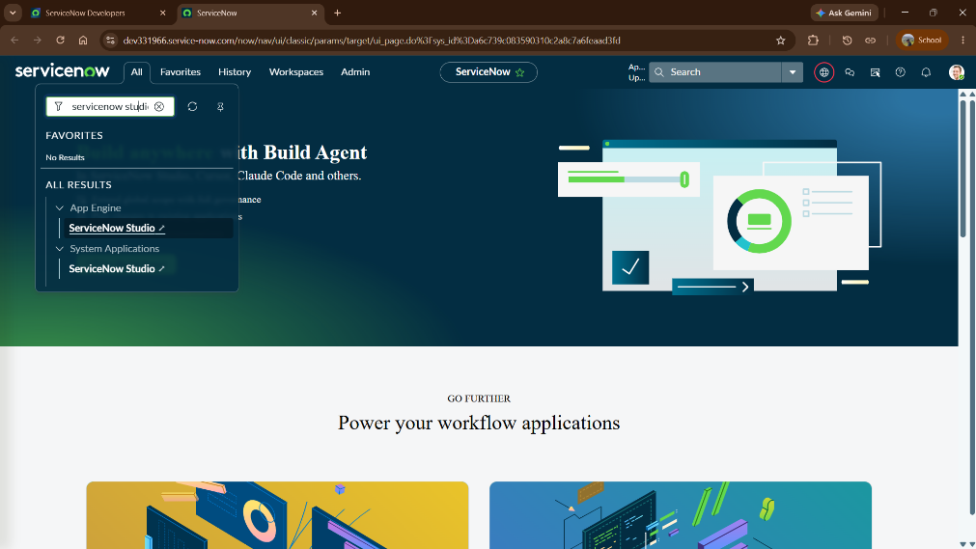

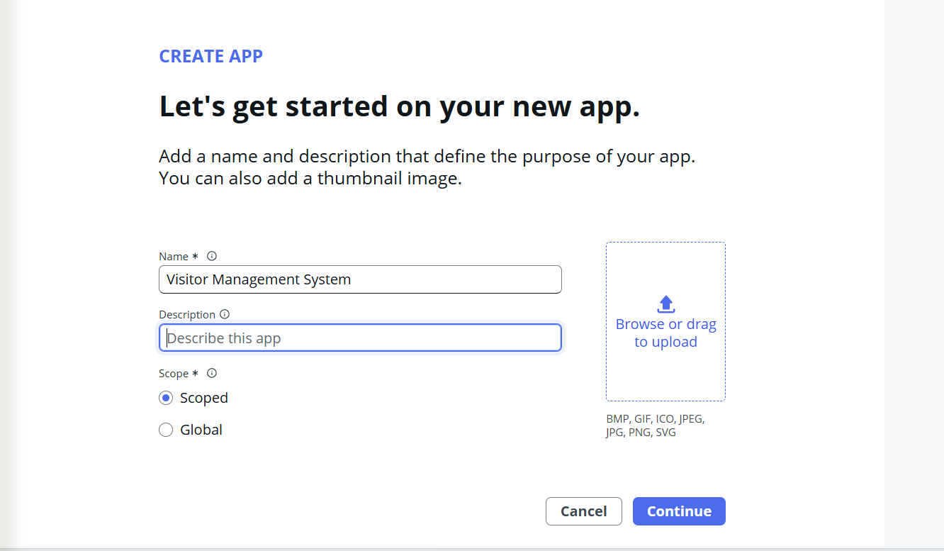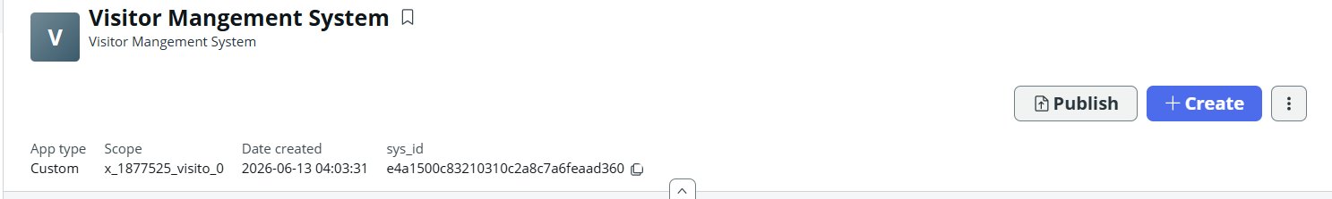

Learning Outcomes
- Understood ServiceNow architecture and application development lifecycle.
- Created and managed a scoped application.
- Configured the ServiceNow development environment.
- Learned ServiceNow Studio fundamentals.
- Understood table creation and relationship management.
- Gained experience in designing custom applications.

